MISSING PERSON
Calvin “Mark” McCullers
Dallas, Texas
Name: | Mark McCullers
Date Missing: | July 5th, 2016
Missing From: | Dallas, Texas
DOB:
Age: | 45
Hair Color: | Grey/Short
Height: | 6’00”
Weight: | 189 lbs
Eye Color:
Sex: | Male
Race: | White
Complexion:
Police/Sheriff:
Officer/Deputy Name: | Keith McCain
Officer’s Phone #: | 214-649-2113
Officer’s Case #:
TES Case #:



Officer Mark McCullers with the SMU Police Department was last seen on video at the Fitzhugh Avenue Bridge in Dallas, Texas at around 1:39 a.m. on July 5th, 2016. Officer McCullers was working off duty at a construction site near Turtle Creek when he called 911 to report that floodwaters were moving his car. Video shows him exiting his vehicle seconds before being swept downstream. He is believed to have been wearing a t-shirt and dark blue uniform pants. He is presumed drowned. Please keep the McCullers family in your prayers. Any information concerning his location should be directed to Sergeant McCain at (214) 649-2113 or call Texas EquuSearch at (281) 309-9500.

Call Toll Free 877-270-9500
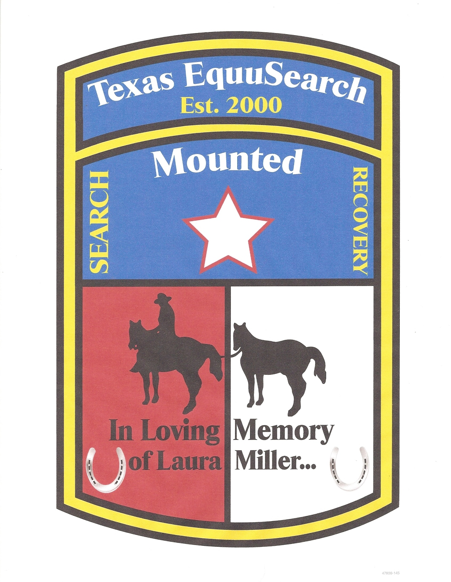
Call Main: 281-309-9500 info@TexasEquuSearch.org

