MISSING PERSON
Charles E. Jackson Jr.
Mobile, Alabama
Name: | Charles E. Jackson Jr.
Date Missing: | May 22nd 2014
Missing From: | Mobile, Alabama
DOB: | March 1st 1981
Age: | 33 Years-Old
Hair Color: | Very Short Brown
Height: | 5’ 9”
Weight: | About 190 lbs.
Eye Color: | Brown
Sex: | Male
Race: | White
Complexion: | Olive
Police/Sheriff: | Mobile, Alabama Police Dept.
Officer/Deputy Name: | Det. Michael Ellzey
Officer’s Phone #: | (251) 208-1805
Officer’s Case #: | # M214-05-03496
TES Case #: | #14-1463



33 year-old Charles E. Jackson Jr. was last seen in Citronelle, Alabama on May 22nd 2014. Charles was last known to be wearing a large, bulky red t-shirt, and camouflage-style cargo shorts. Charles has multiple tattoos including those of a tattoo of “Laugh Now” on the inside left forearm, and “Cry Later” on his inside right forearm. He also has the number 13 tattooed on the inside of his wrist. If you have seen Charles E. Jackson Jr. since his disappearance, if you know of his current whereabouts, or if you have any information concerning his disappearance; please contact the Mobile, Alabama Police Department at (251) 208-1805 - or call Texas EquuSearch at (281) 309-9500.

Call Toll Free 877-270-9500
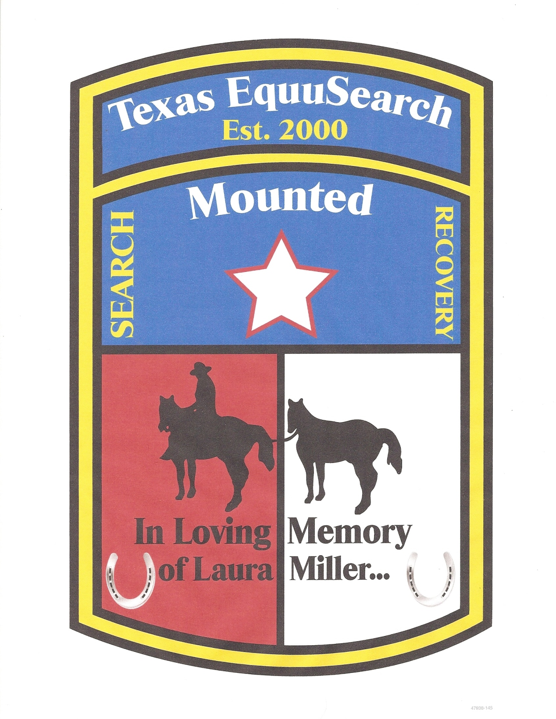
Call Main: 281-309-9500 info@TexasEquuSearch.org

